Name : Mriganka Patra

Email ID: mriganka.patra@cognizant.com

Task 1: Create New Campaign named 'Summer Product Launch 2025' and add 3 Leads to the Campaign.

1. Navigate to the Campaigns tab in Salesforce.
2. 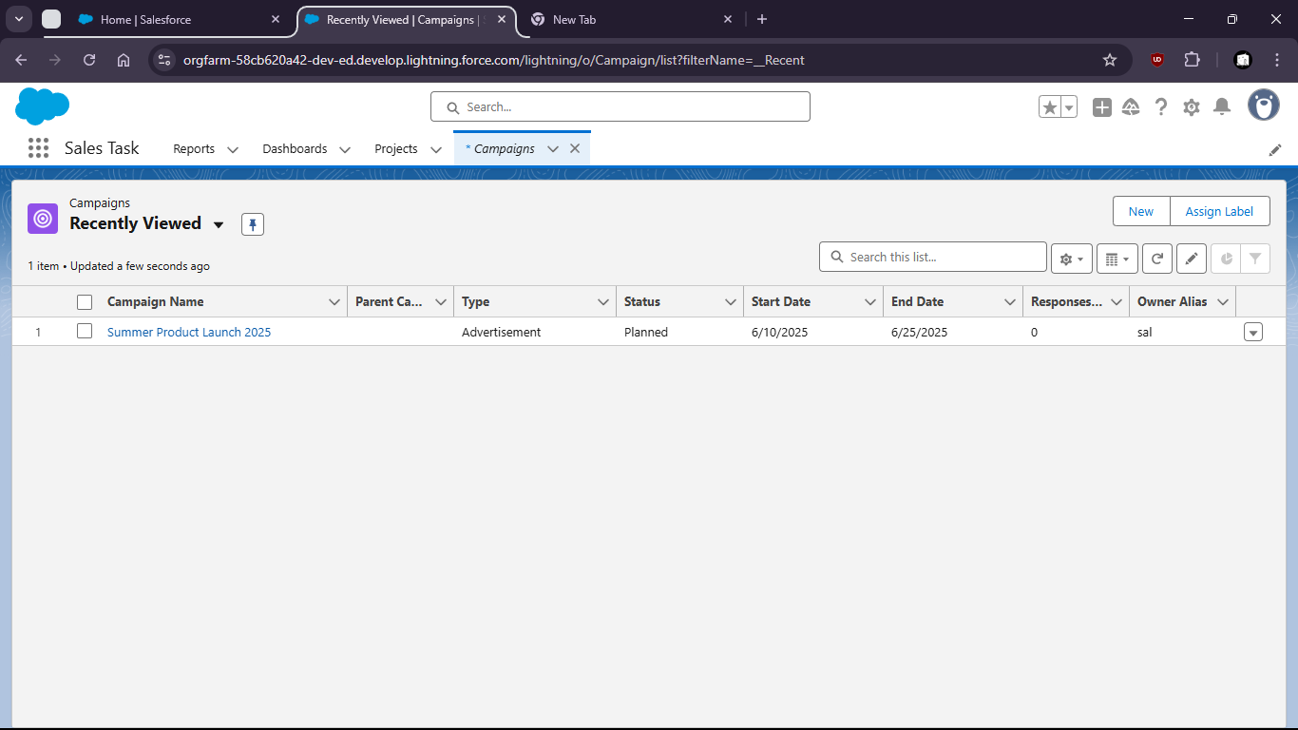
3. Click on New
4. 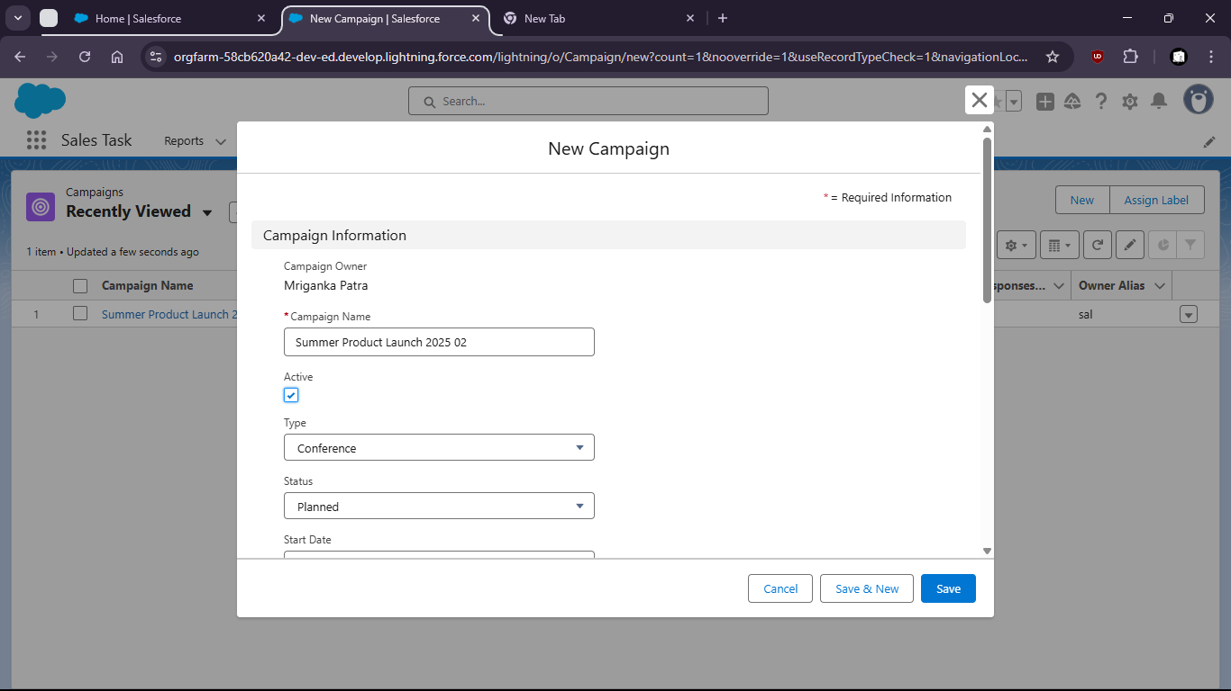
5. 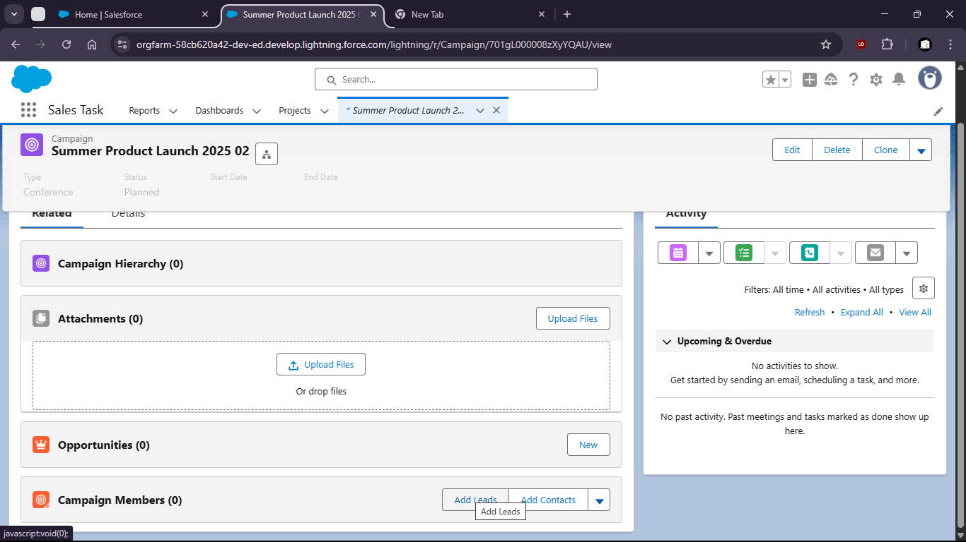
6. Click on New Lead
7. Lead 1
8. 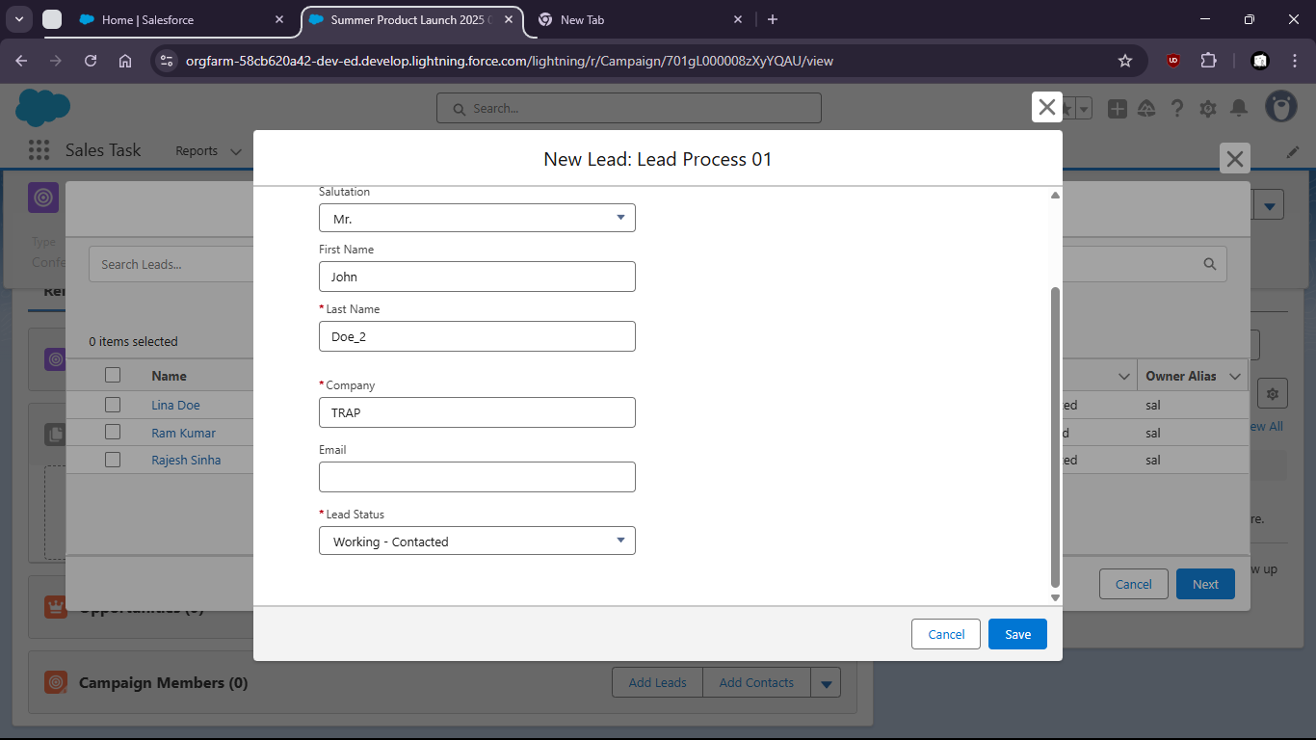
9. Lead 2
10. 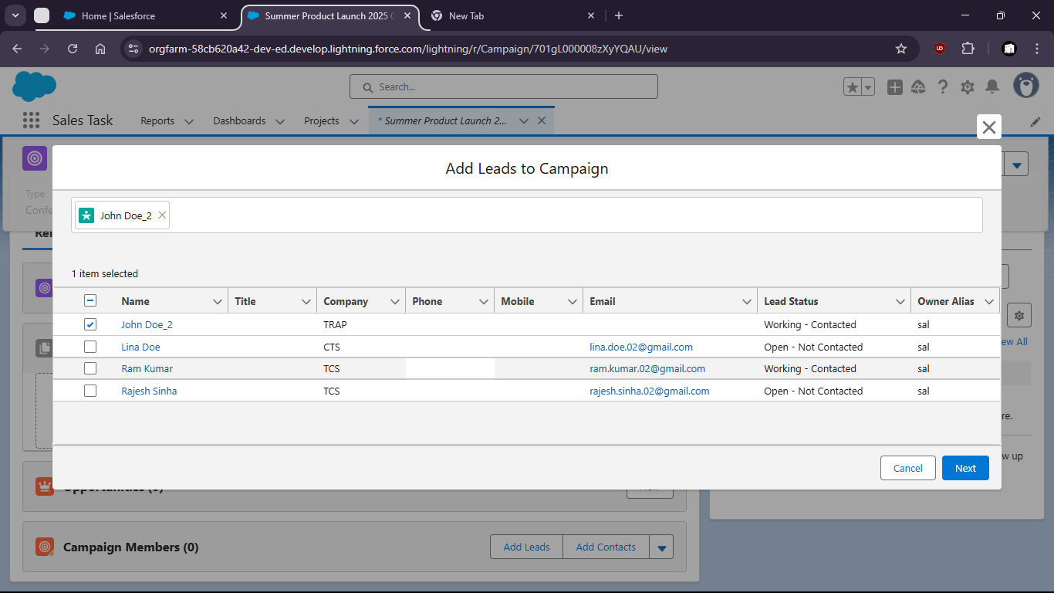
11. Lead 3
12. 
13. Now click on Add Leads under Campaign members
14. 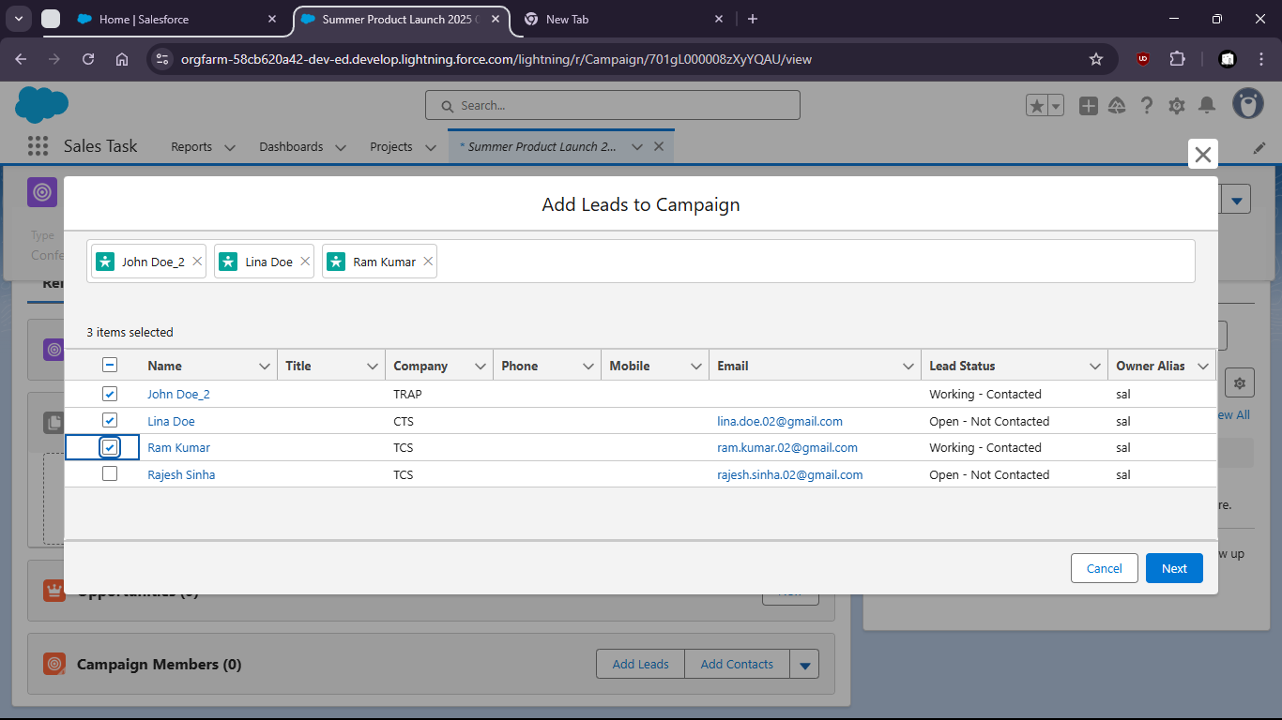
15. Select the Leads and click next
16. 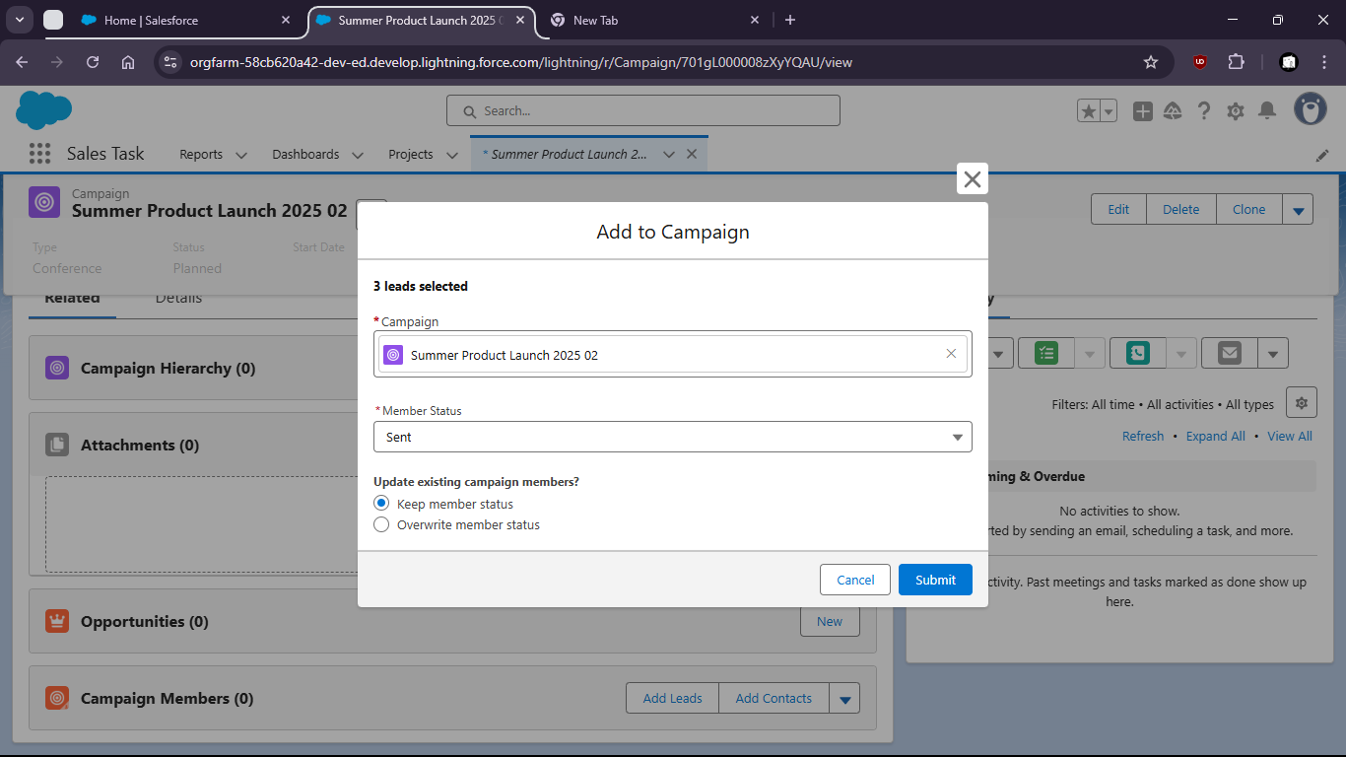
17. Leads added
18. 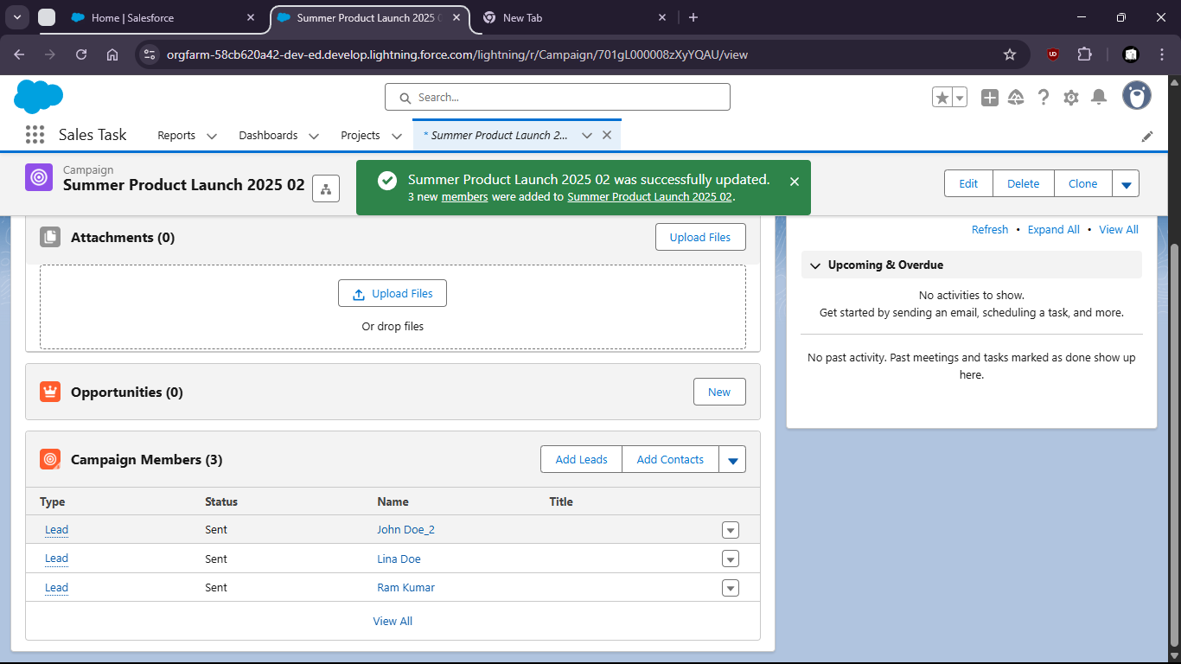

Task 2: Track Campaign influence and status changes across the Sales funnel.

1. Go to the App Launcher and search for Reports
2. 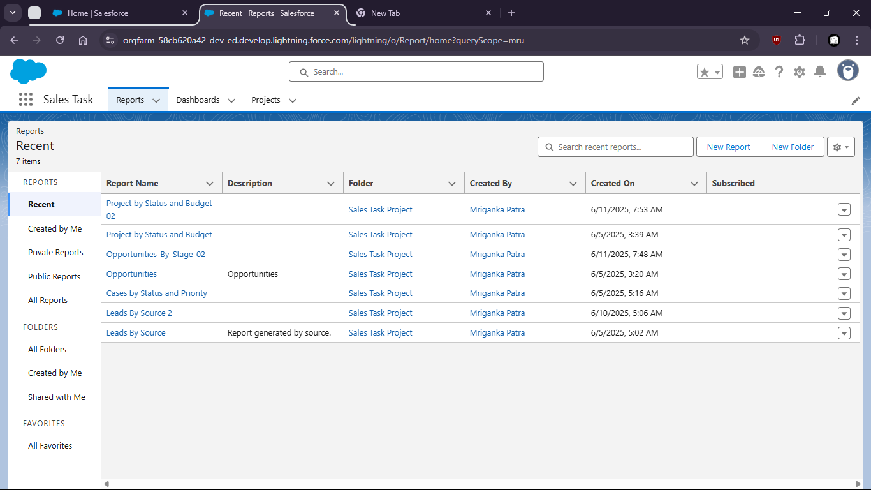
3. Click on New Report
4. Select Campaigns with opportunity
5. 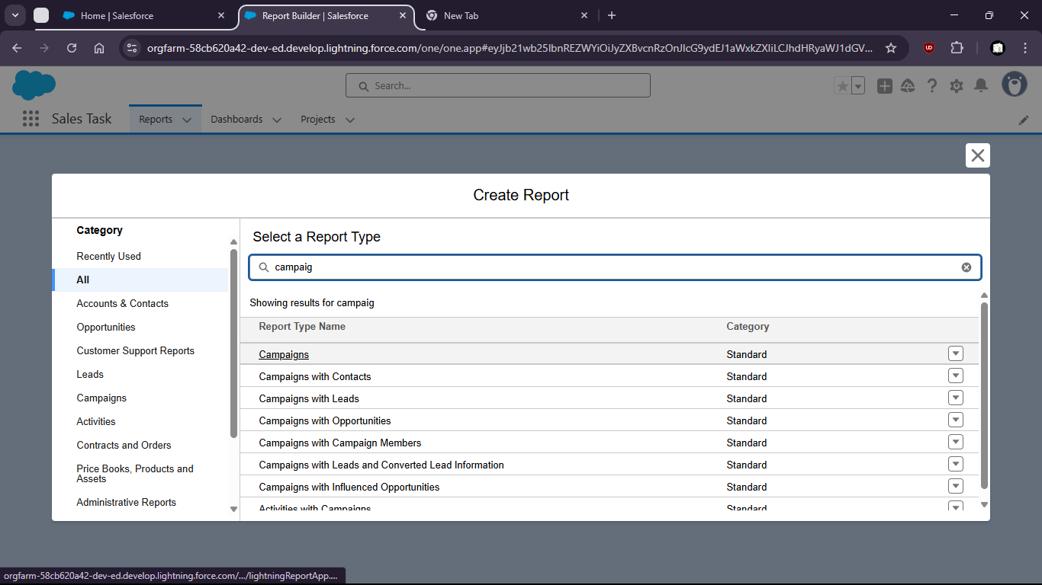

Task 3: Create 3 new Products with unique names and unique prices

1. Go to the App Launcher and type "Products"

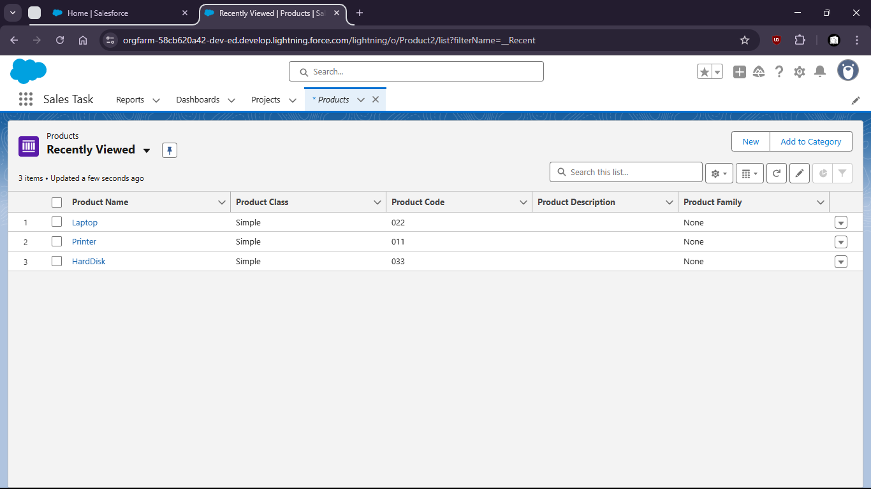

1. Click on New and Create Product1
2. 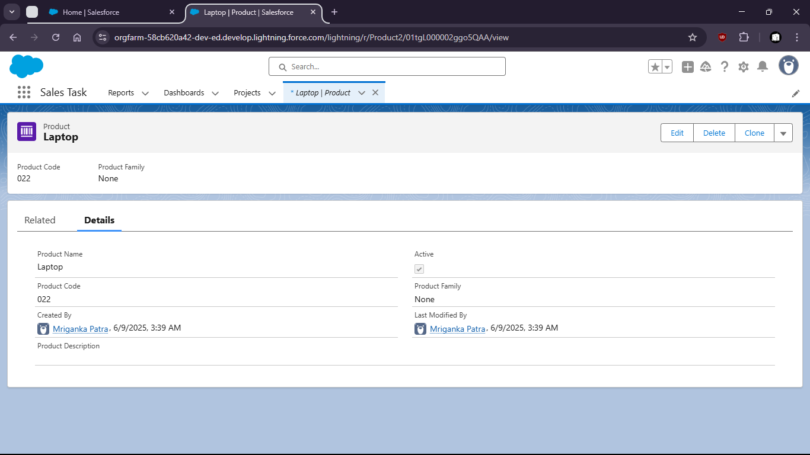
3. Create Product#2
4. 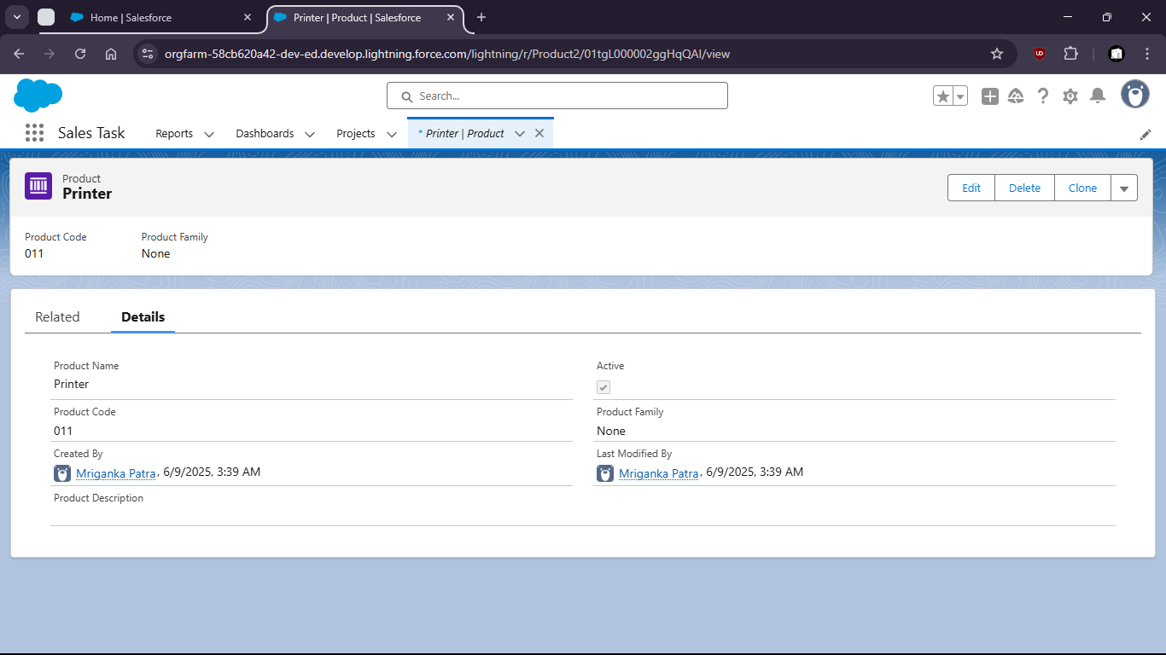
5. Create Product#3
6. 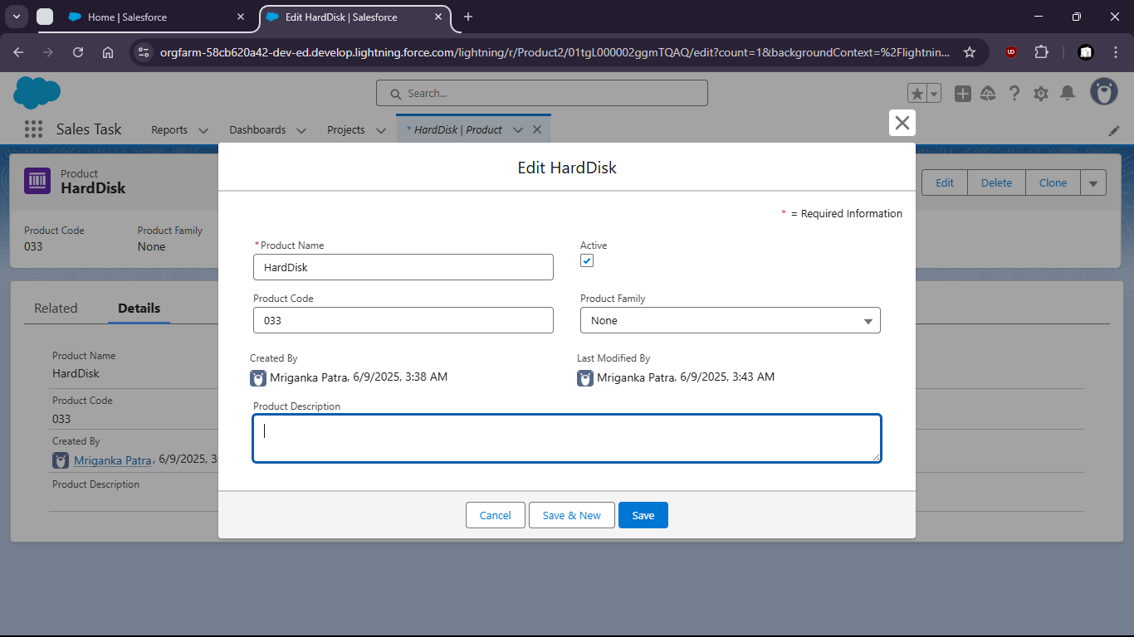
7. All created Products
8. 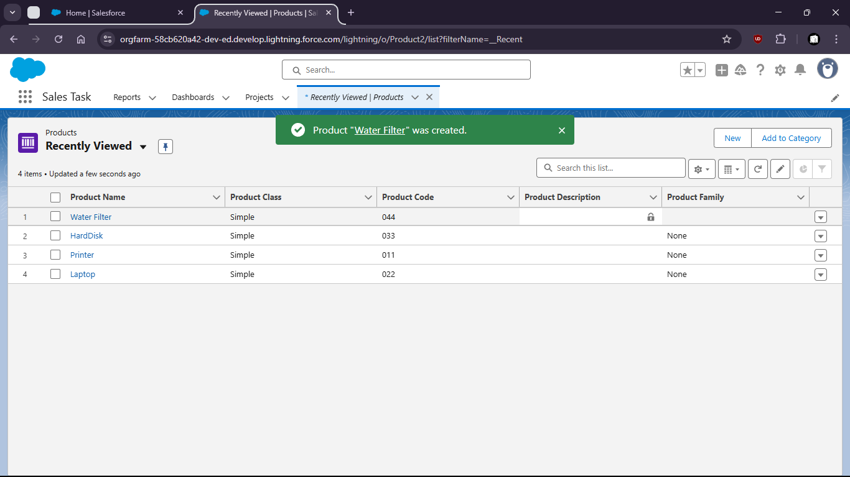
9. Now open ‘Laptop’ product then go to ‘Related’
10. 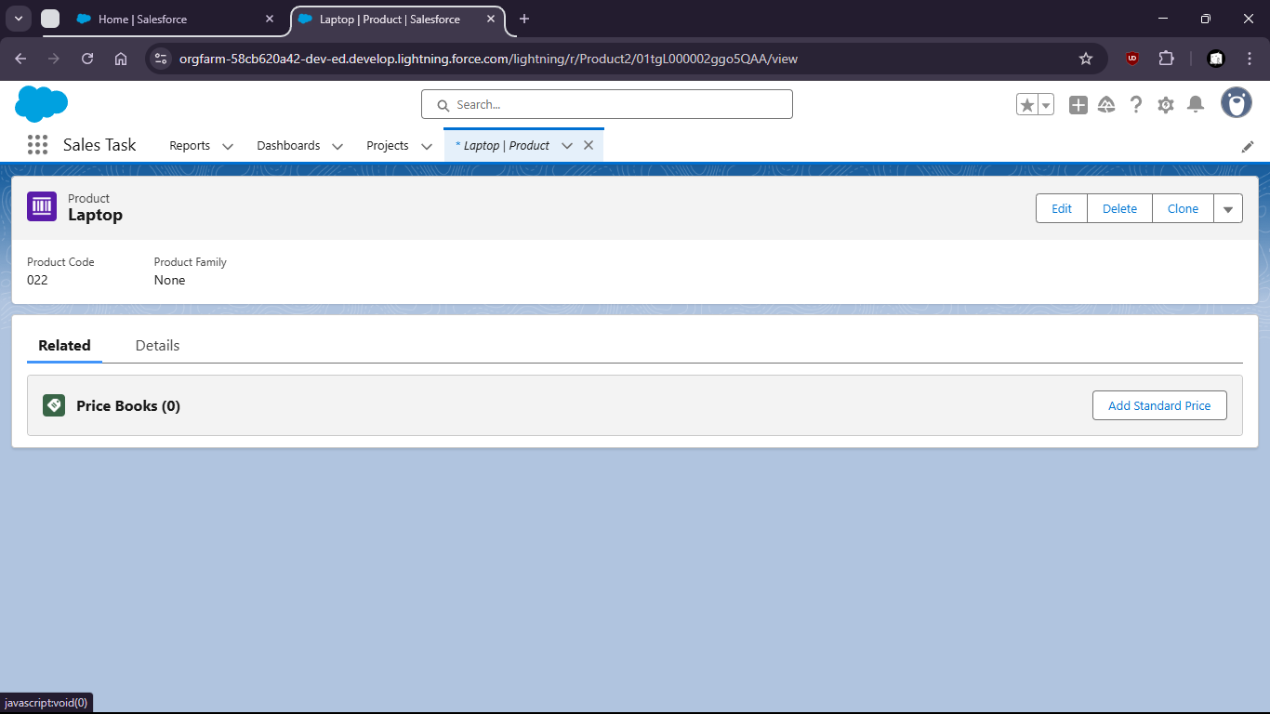
11. Click on ‘Add Standard Price’ and add Price
12. 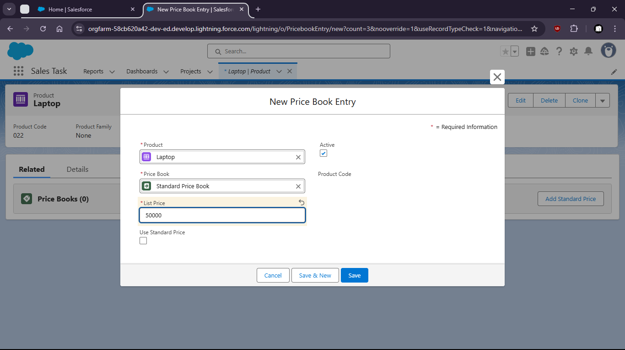

Task 4: Define custom Pricebook and associate the created products with different prices.

1. Go to Pricebooks
2. 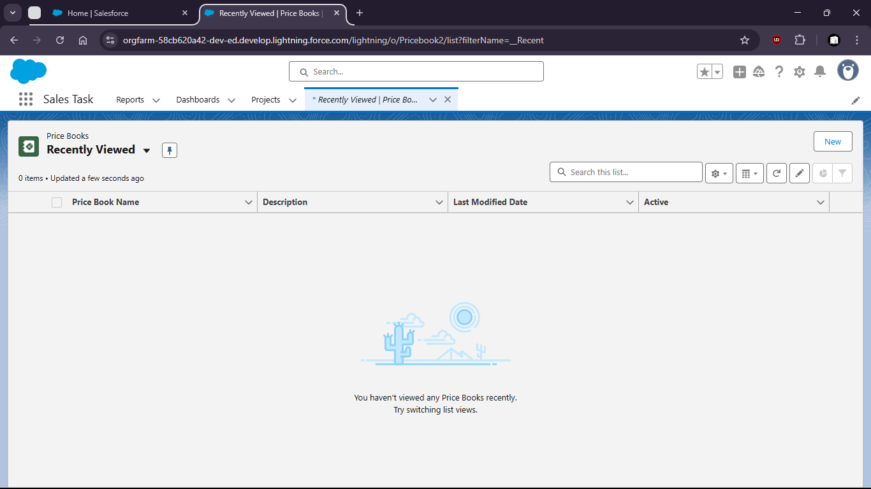
3. 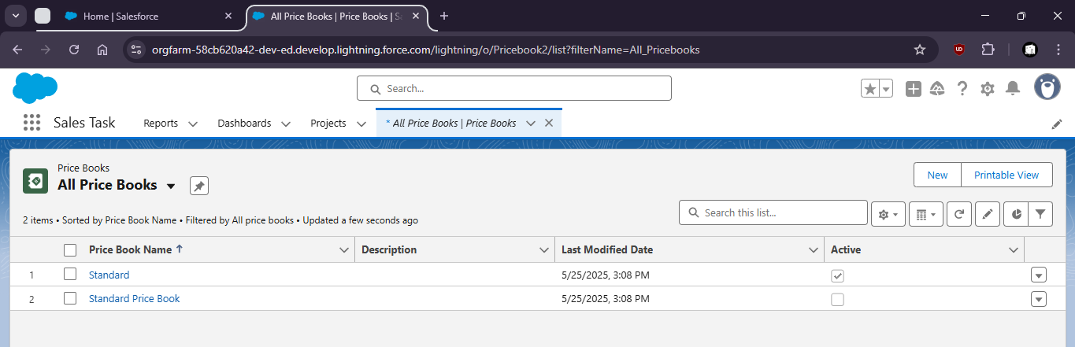
4. Click New and create Summer Price Book
5. 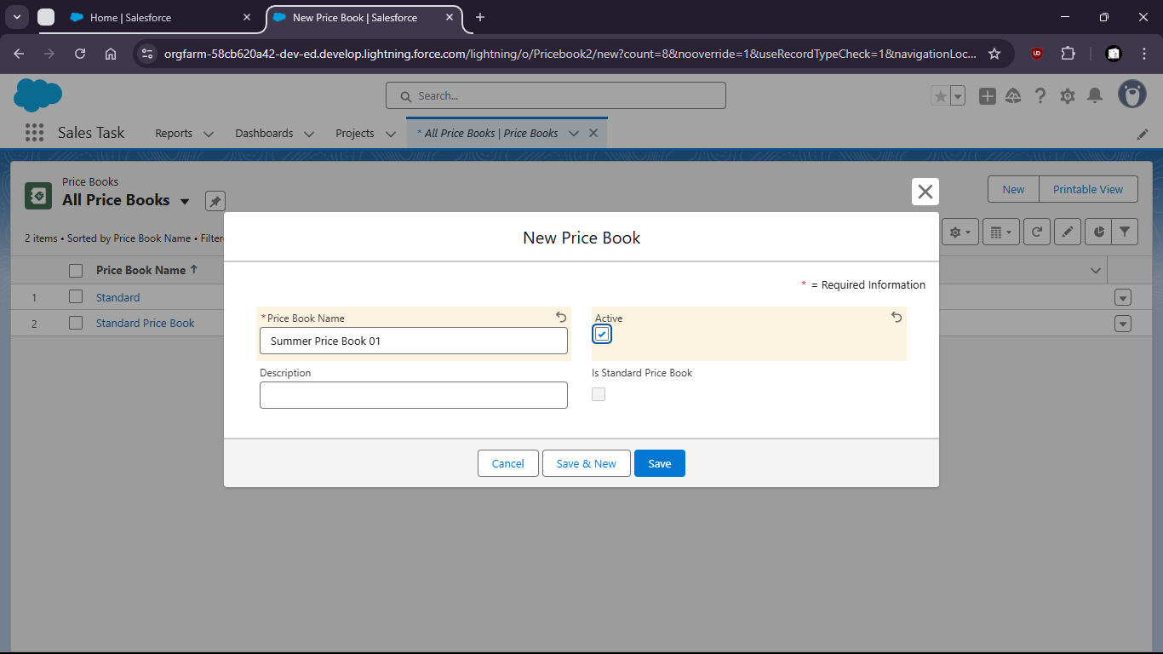
6. Open the Price Book
7. 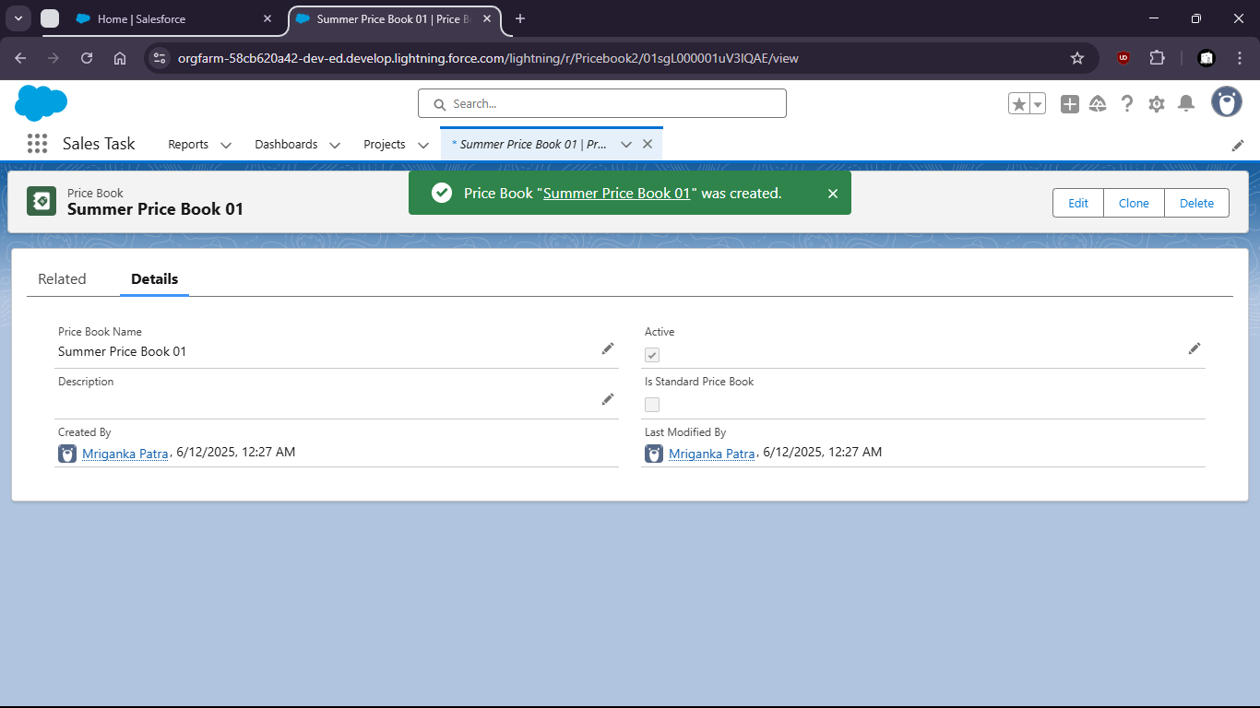
8. 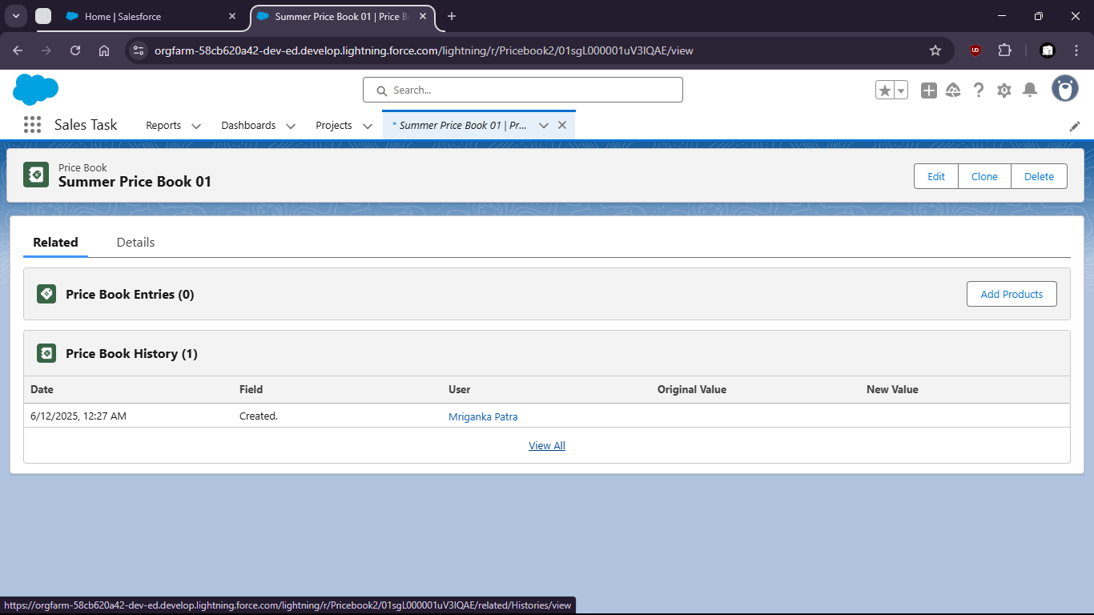
9. Click on Add Products and select products
10. 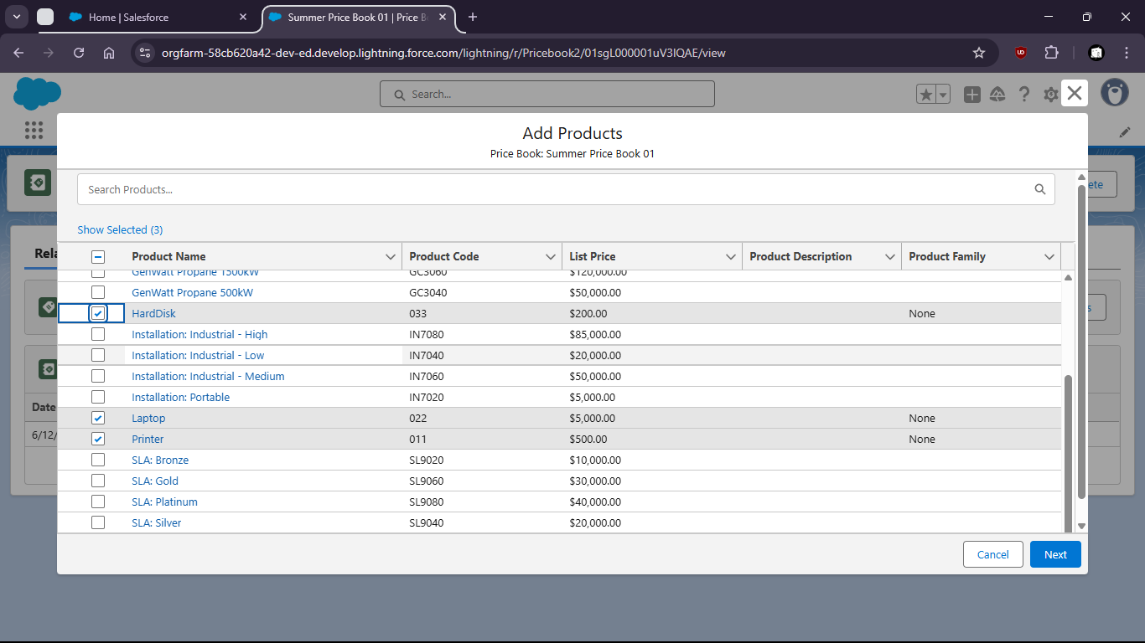
11. Now save it
12. 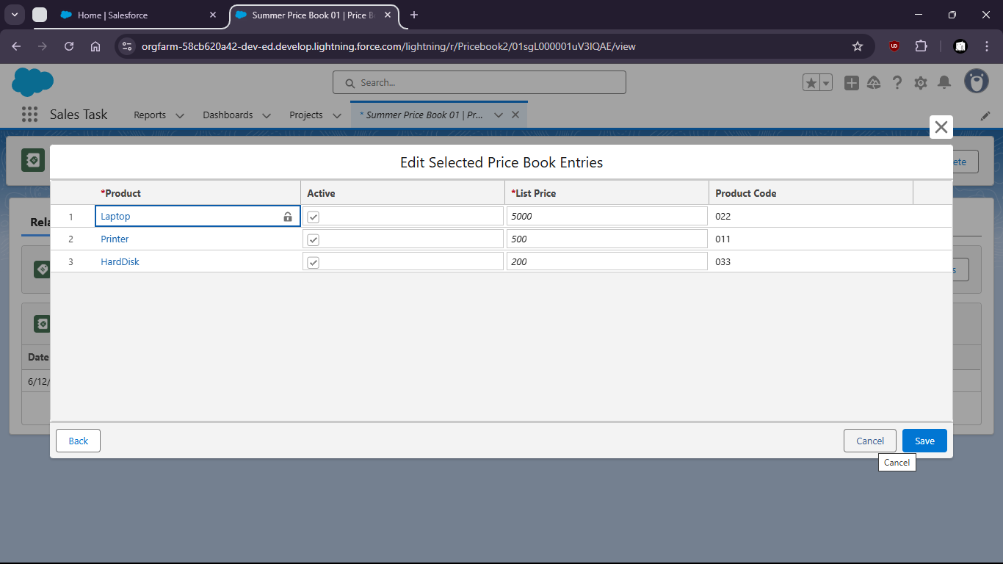
13. 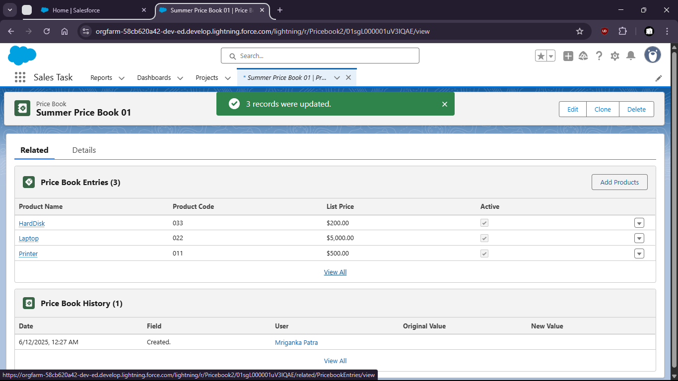

Task 5: Create an opportunity and add products using the custom ‘Pricebook’.

1. Go to Opportunity by searching from App Launcher
2. 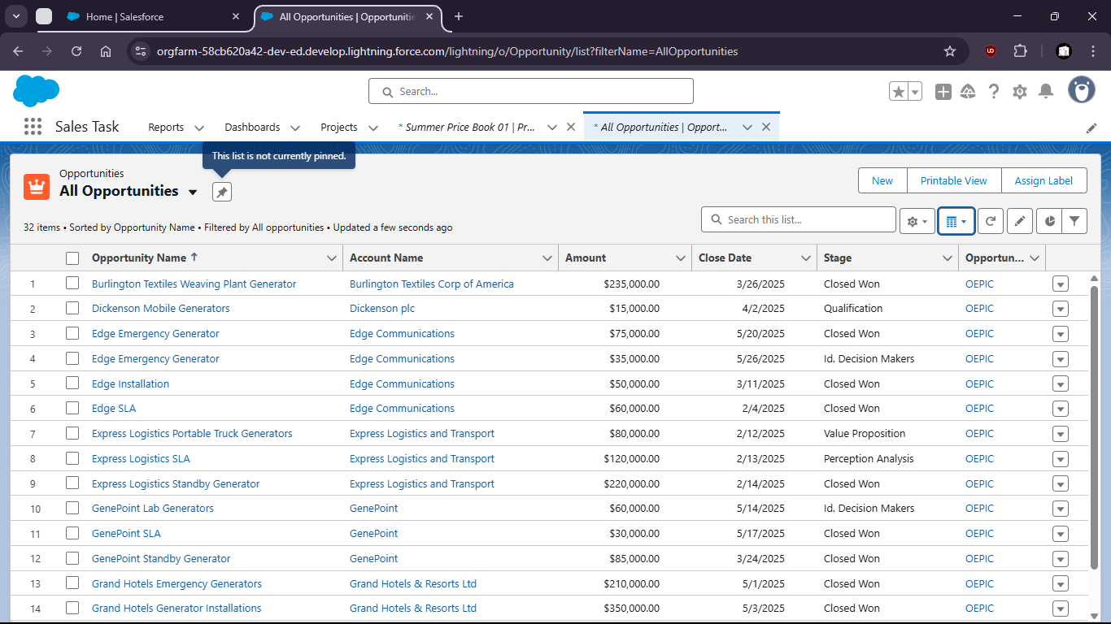
3. Click New and create a new Opportunity
4. 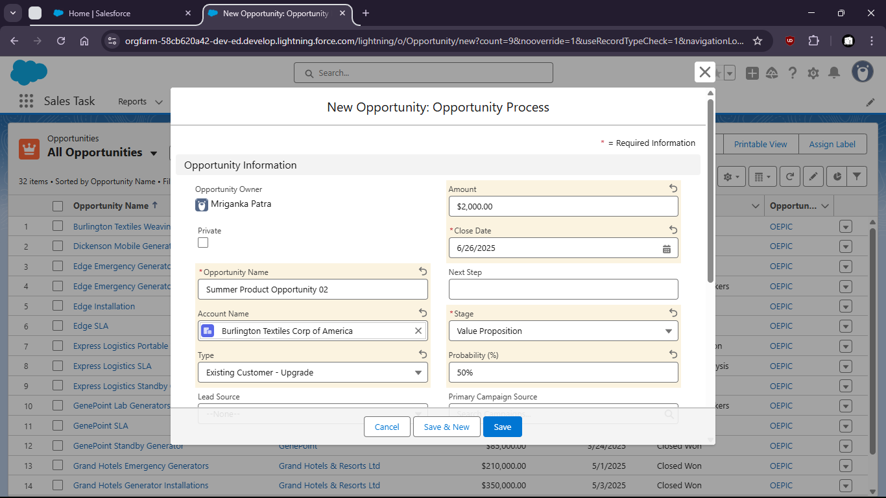
5. 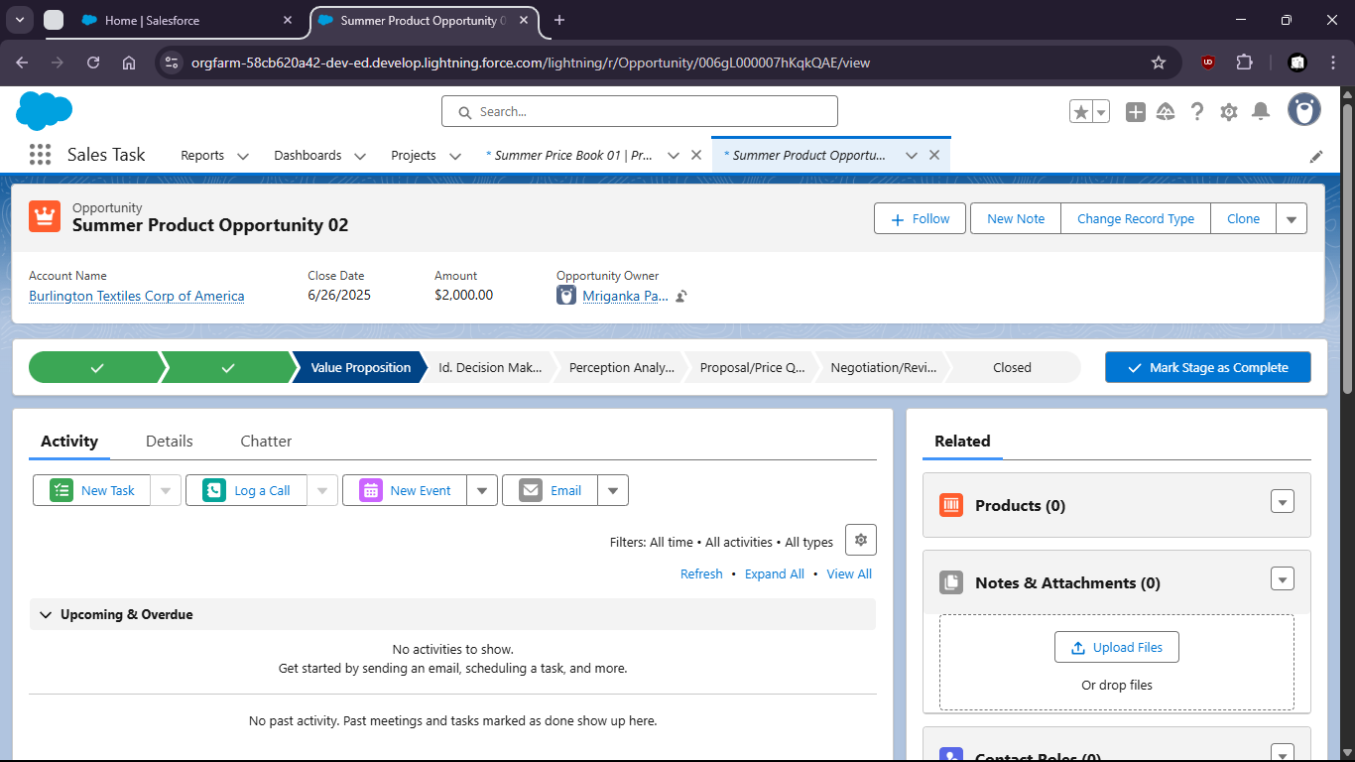
6. Go to Products and click Add Product
7. 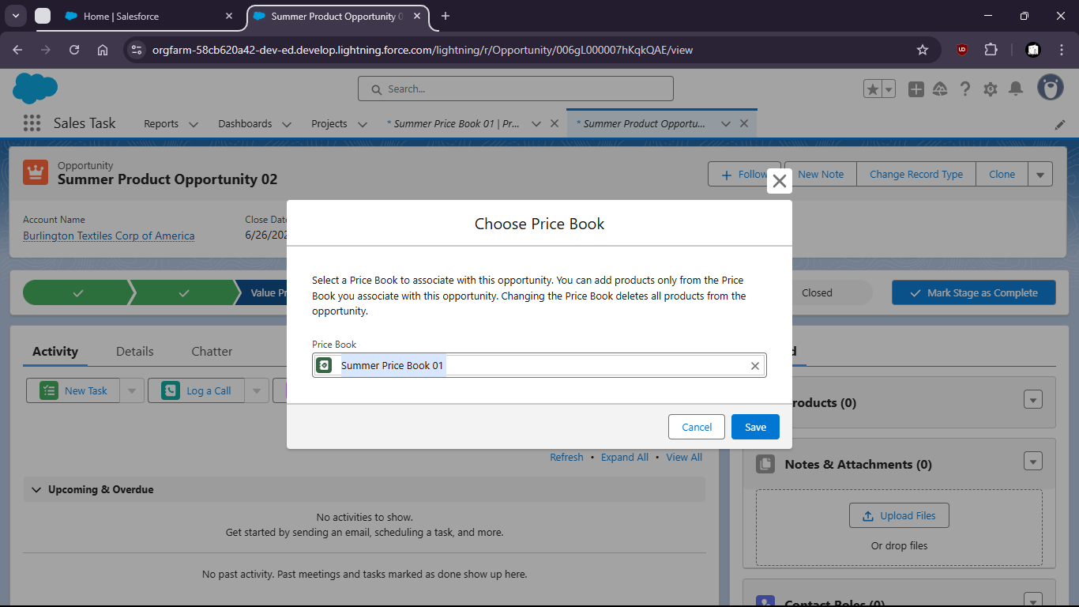
8. 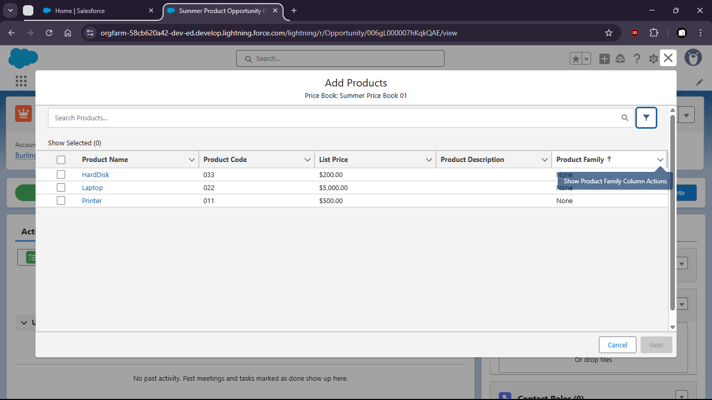
9. 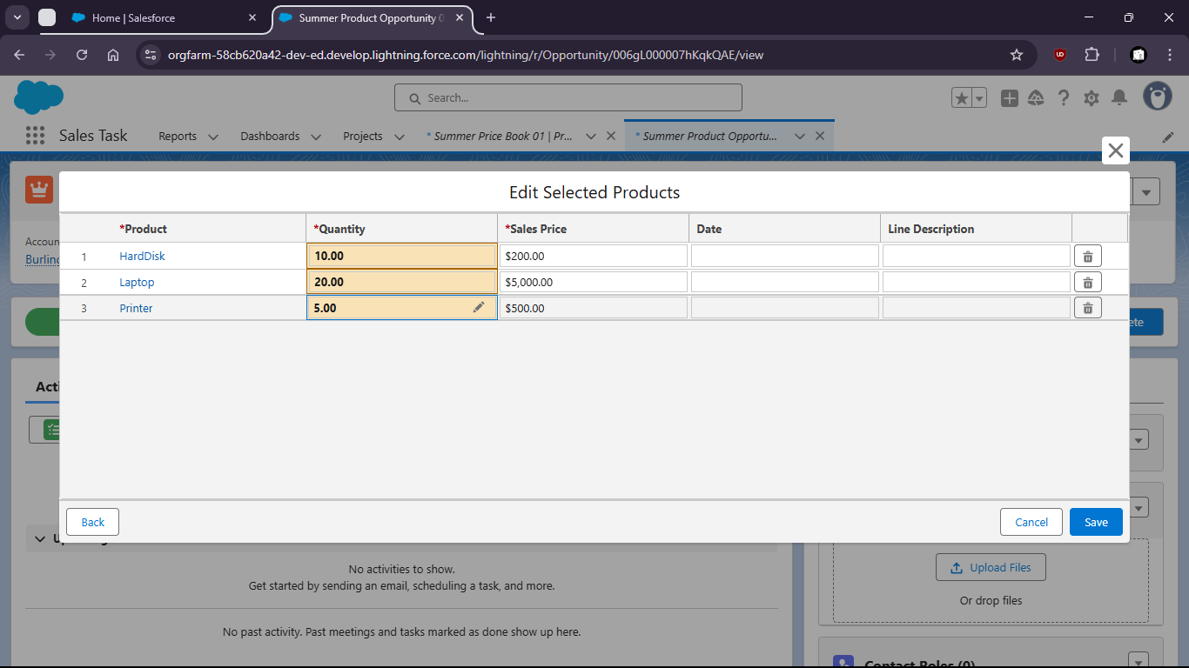
10. 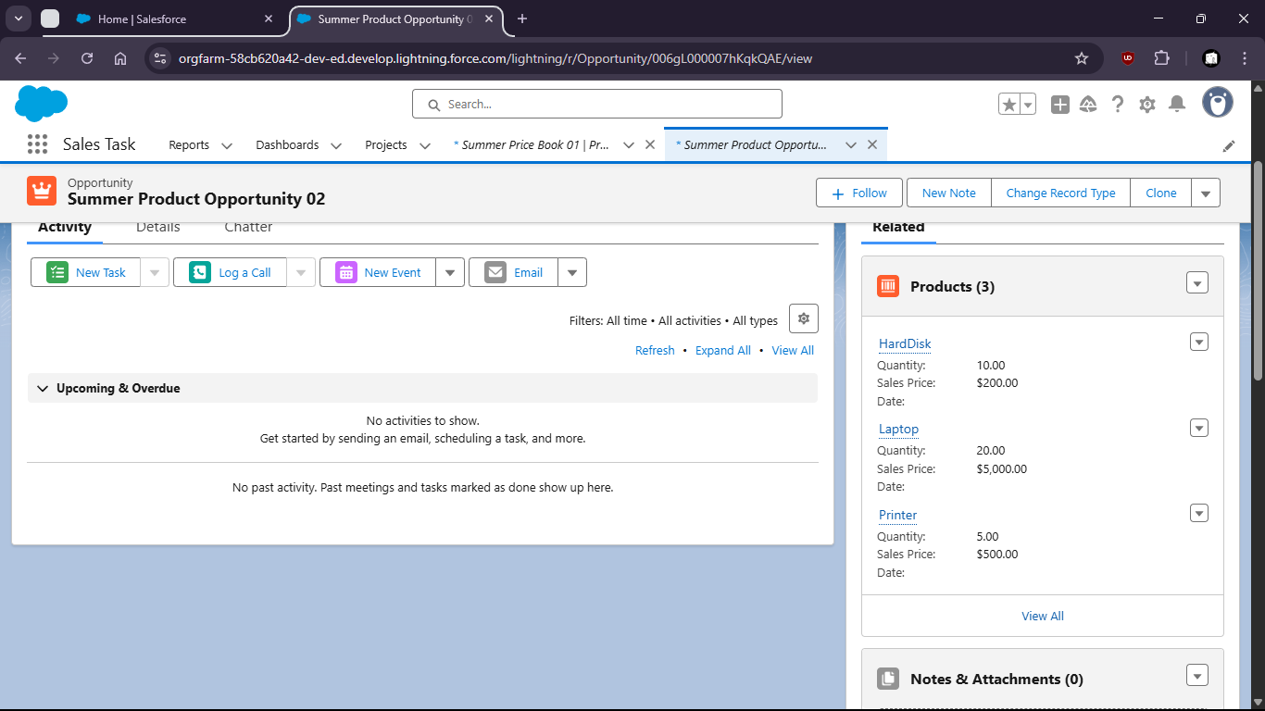

Task 6:

Task 7: